Business Problem

Effective inventory and sales management are critical for optimizing profitability in the retail and wholesale industry. Companies need to ensure that they are not incurring losses due to inefficient pricing, poor inventory turnover, or vendor dependency. The goal of this analysis is to:

* Identify underperforming brands that require promotional or pricing adjustments.
* Determine top vendors contributing to sales and gross profit.
* Analyze the impact of bulk purchasing on unit costs.
* Assess inventory turnover to reduce holding costs and improve efficiency.
* Investigate the profitability variance between high-performing and low-performing vendors.

**Exploratory Data Analysis Insights**

# Summary Statistics

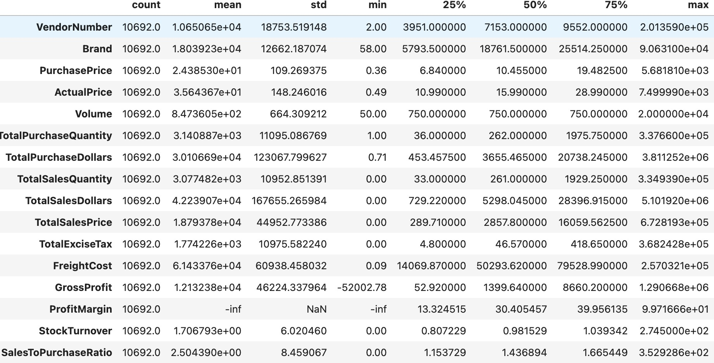

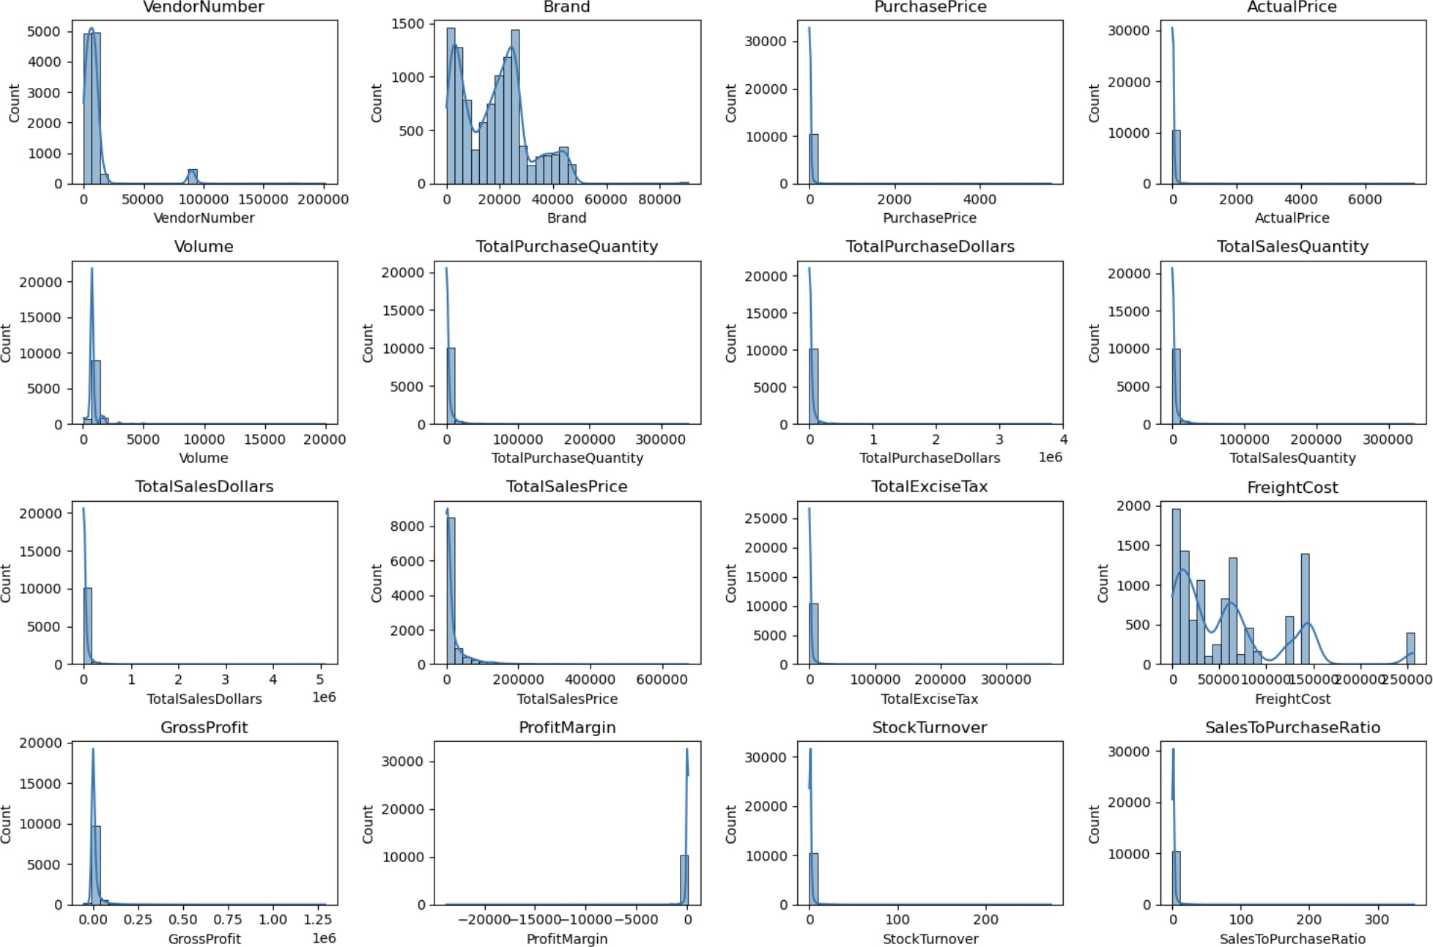

## Negative & Zero Values:

**Gross Profit:** A minimum of -52,002.78, which suggests possible losses as a result of excessive expenses or significant discounts. This might be the result of things being sold for less than what they cost to buy.

**Profit Margin:** has a minimum of -∞, indicating situations in which profit margins are extremely negative due to revenue being zero or even less than the whole cost.

**Total Sales Quantity & Sales Dollars:** Zero sales indicate that some things were bought but never sold. Inventory inefficiencies may result from these slow-moving or outdated items.

## Outliers Detected by High Standard Deviations:

**Purchase & Actual Prices:** Premium product offers are indicated by the maximum values (5,681.81 & 7,499.99), which are noticeably higher than the mean (24.39 & 35.64).

**Freight Cost:** Extreme variation from 0.09 to 257,032.07 suggests logistics inefficiencies, bulk shipments, or erratic shipping costs across different products.

**Stock Turnover:** ranges from 0 to 274.5, indicating that while some things sell quickly, others go unsold for extended periods of time. When a figure is more than 1, it means that older stock is completing orders, which results in higher sales of the product than was originally acquired.

After removing outliers--

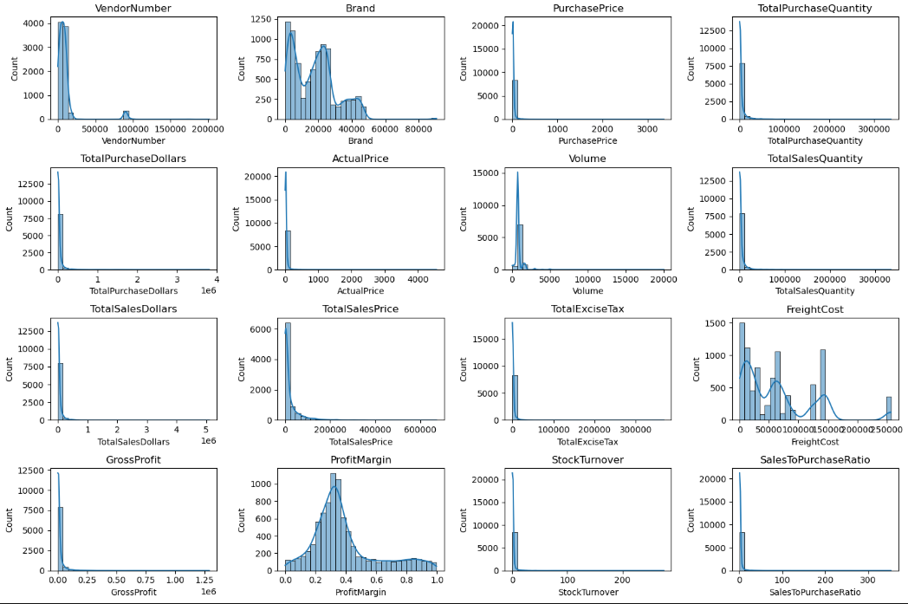

# Data Filtering

To enhance the reliability of the insights, we removed inconsistent data points where:

* Gross Profit ≤ 0 (to exclude transactions leading to losses).
* Profit Margin ≤ 0 (to ensure analysis focuses on profitable transactions).
* Total Sales Quantity = 0 (to eliminate inventory that was never sold).

# Correlation Insights

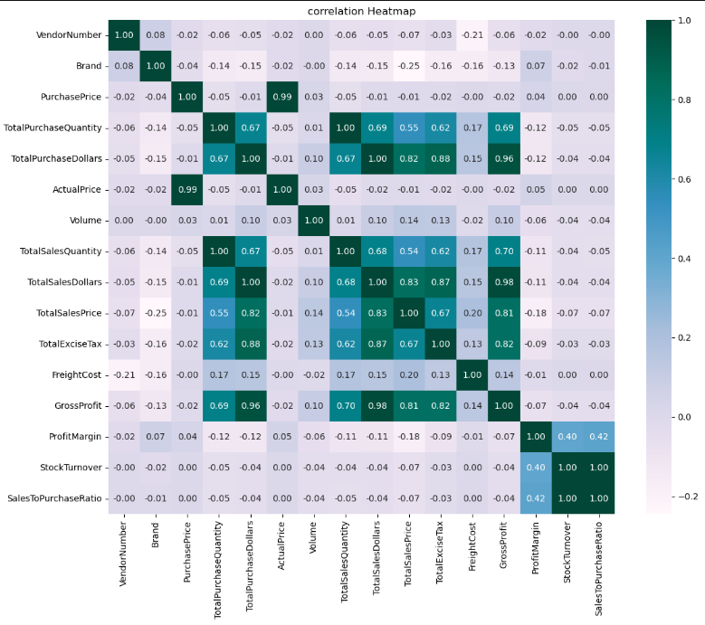

**Purchase Price vs. Total Sales Dollars & Gross Profit:** Weak correlation (-0.012 and -0.016), indicating that price variations do not significantly impact sales revenue or profit.

**Total Purchase Quantity vs. Total Sales Quantity:** Strong correlation (0.999), confirming efficient inventory turnover.

**Profit Margin vs. Total Sales Price:** Negative correlation (-0.179), suggesting increasing sales prices may lead to reduced margins, possibly due to competitive pricing pressures.

**Stock Turnover vs. Gross Profit & Profit Margin:** Weak negative correlation (-0.038 & -0.055), indicating that faster stock turnover does not necessarily equate to higher profitability.

# Research Questions & Key Findings

## Brands for Promotional or Pricing Adjustments

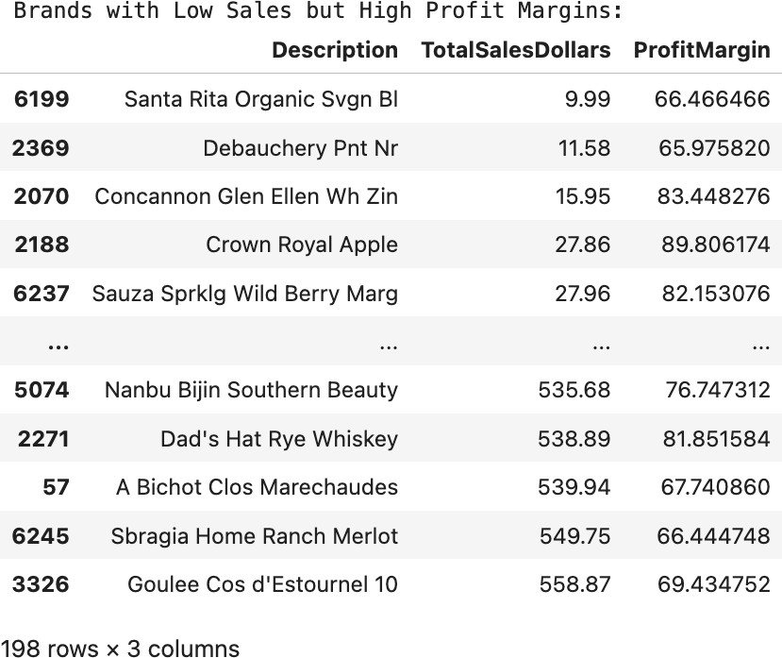

198 brands exhibit lower sales but higher profit margins, which could benefit from targeted marketing, promotions, or price optimizations to increase volume without compromising profitability.

1. **Identify Brands that needs Promotional or Pricing Adjustments which exhibit lower sales performance but higher profit margins**

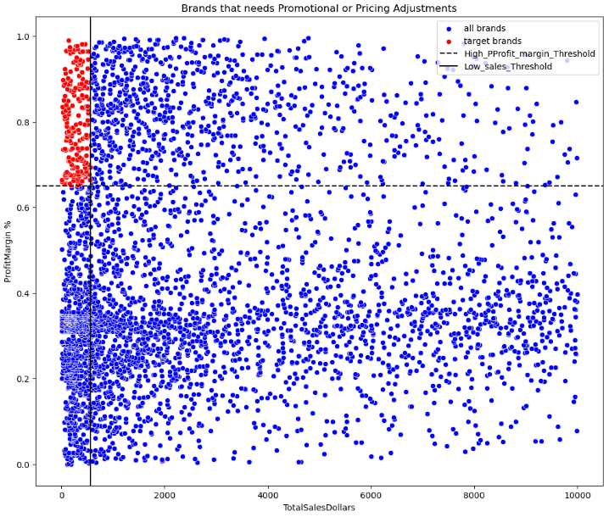

## Top Vendors by Sales & Purchase Contribution

The top 10 vendors contribute 65.69% of total purchases, while the remaining vendors contribute only 34.31%. This over-reliance on a few vendors may introduce risks such as supply chain disruptions, indicating a need for diversification.

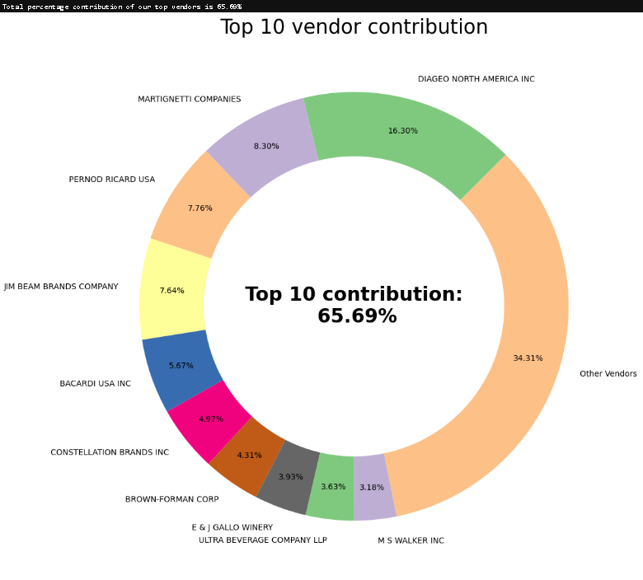

## Impact of Bulk Purchasing on Cost Savings

Vendors buying in large quantities receive a 72% lower unit cost ($10.78 per unit vs. higher unit costs in smaller orders).

Bulk pricing strategies encourage larger orders, increasing total sales while maintaining profitability.

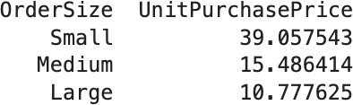

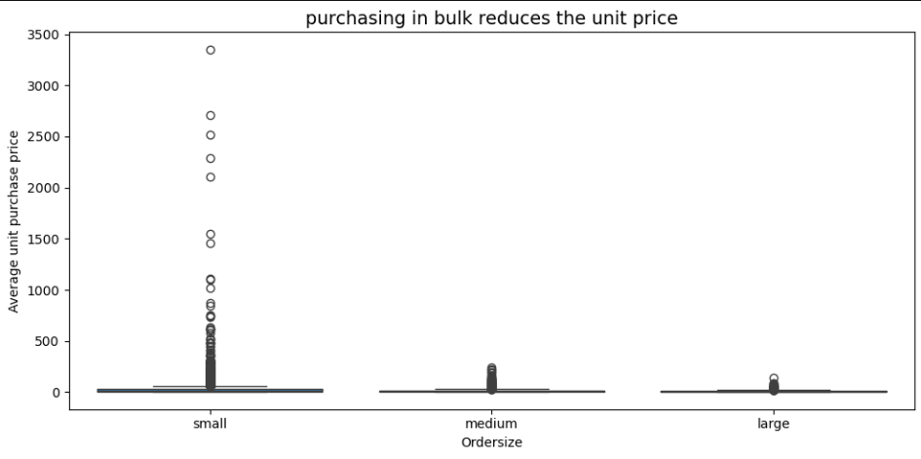

## Identifying Vendors with Low Inventory Turnover

Total Unsold Inventory Capital: **$2.71M**

Slow-moving inventory increases storage costs, reduces cash flow efficiency, and affects overall profitability.

Identifying vendors with low inventory turnover enables better stock management, minimizing financial strain.

